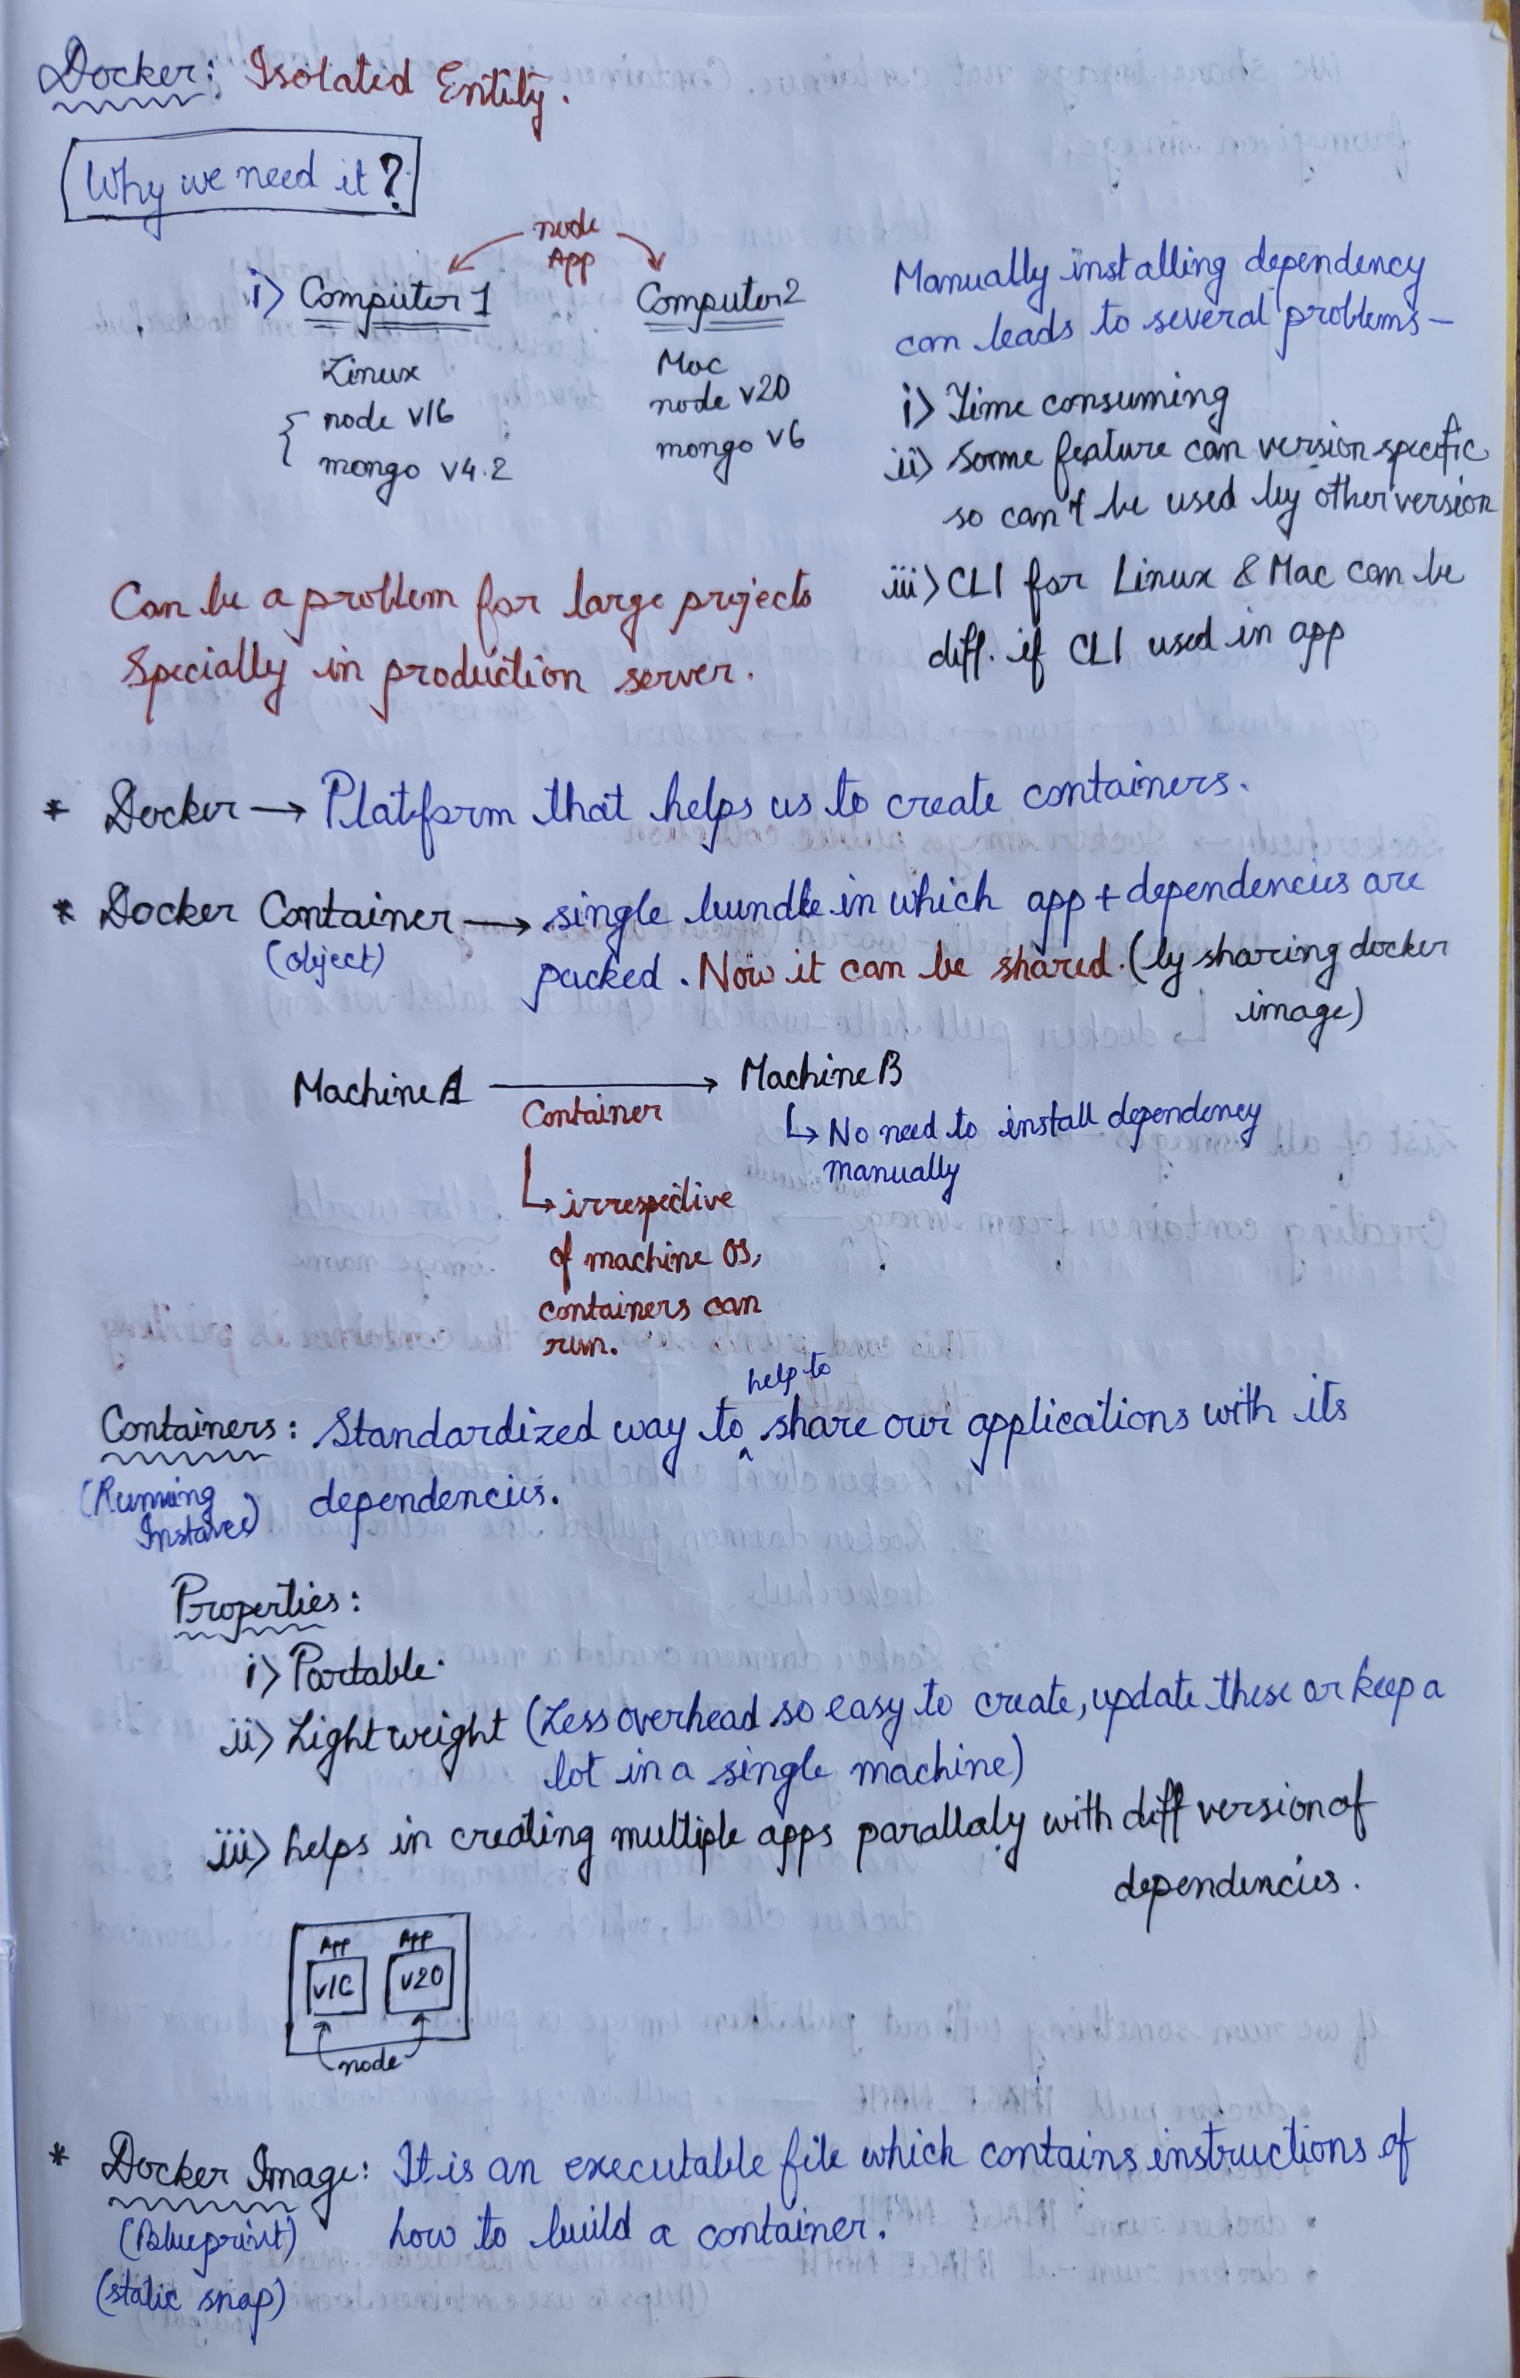

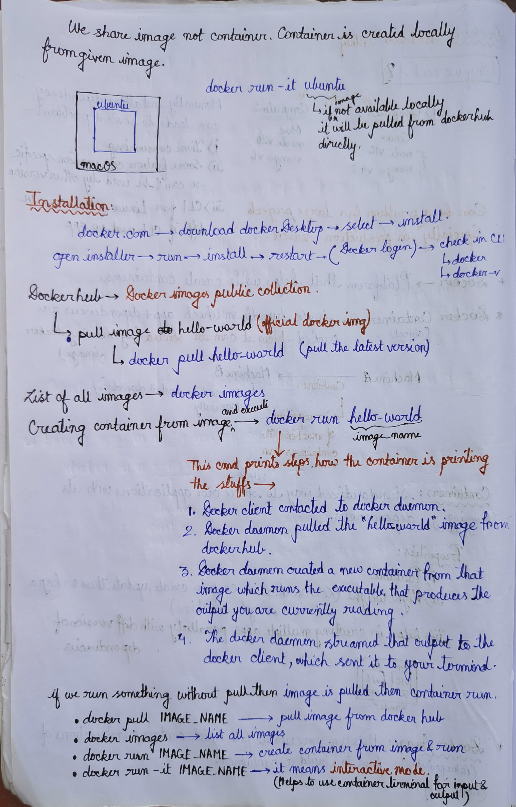

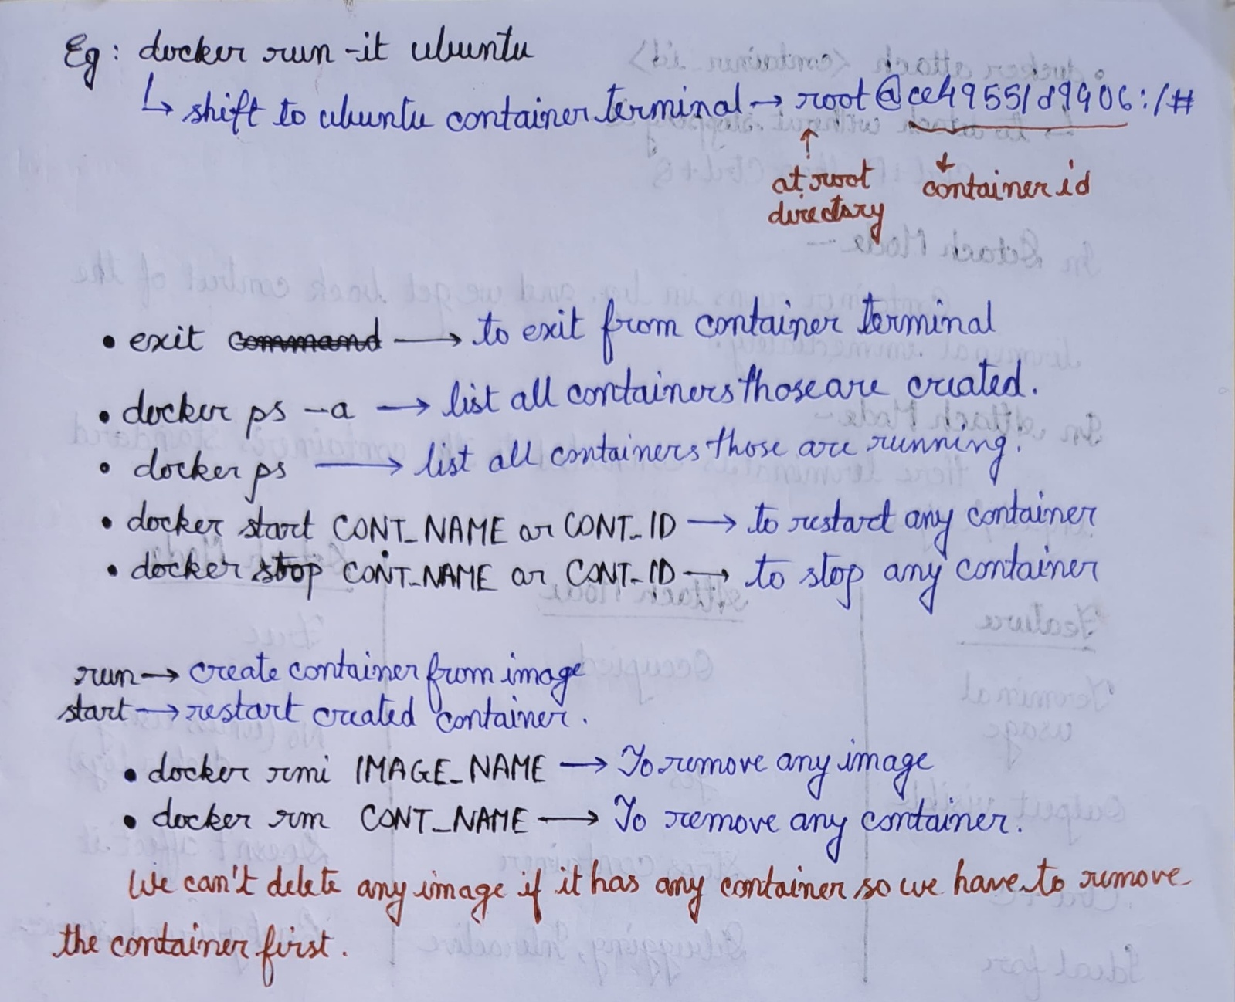

**Docker Version-**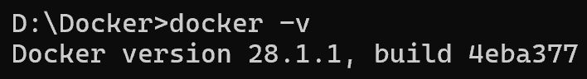

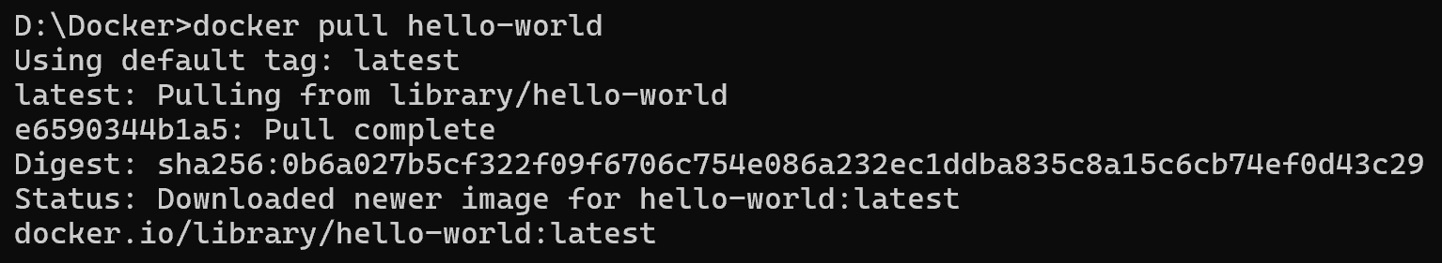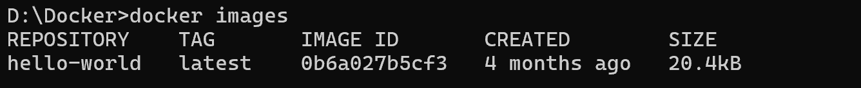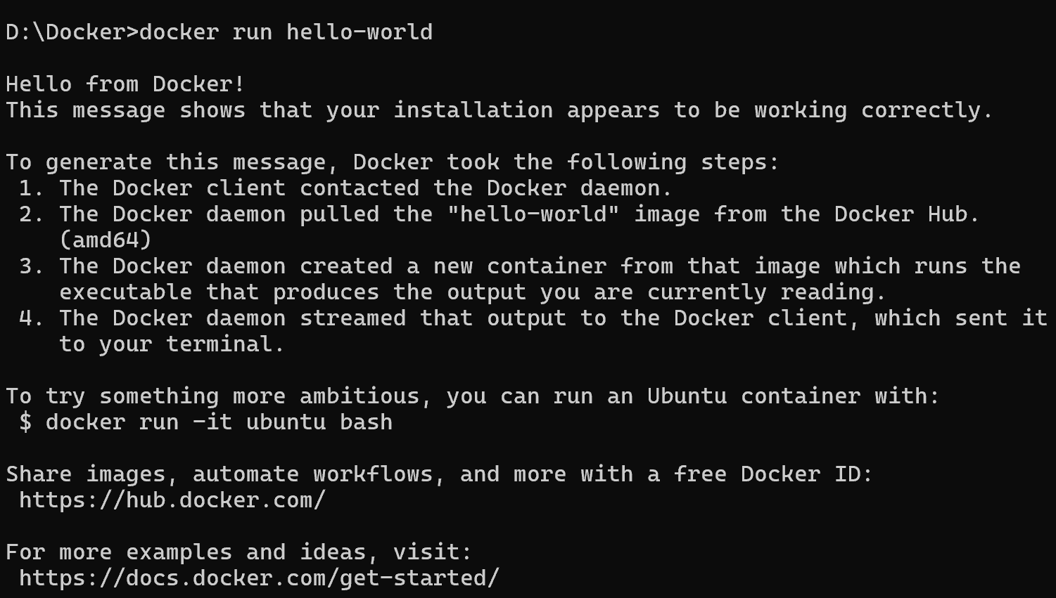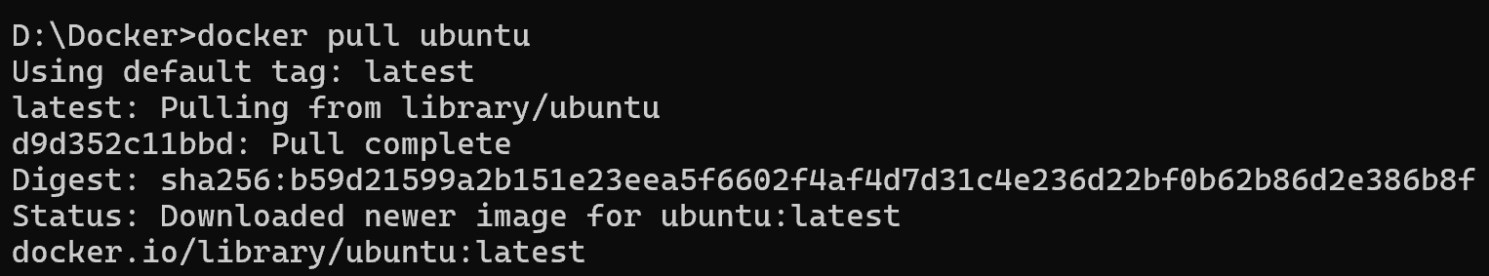

**Shift to ubuntu container terminal** 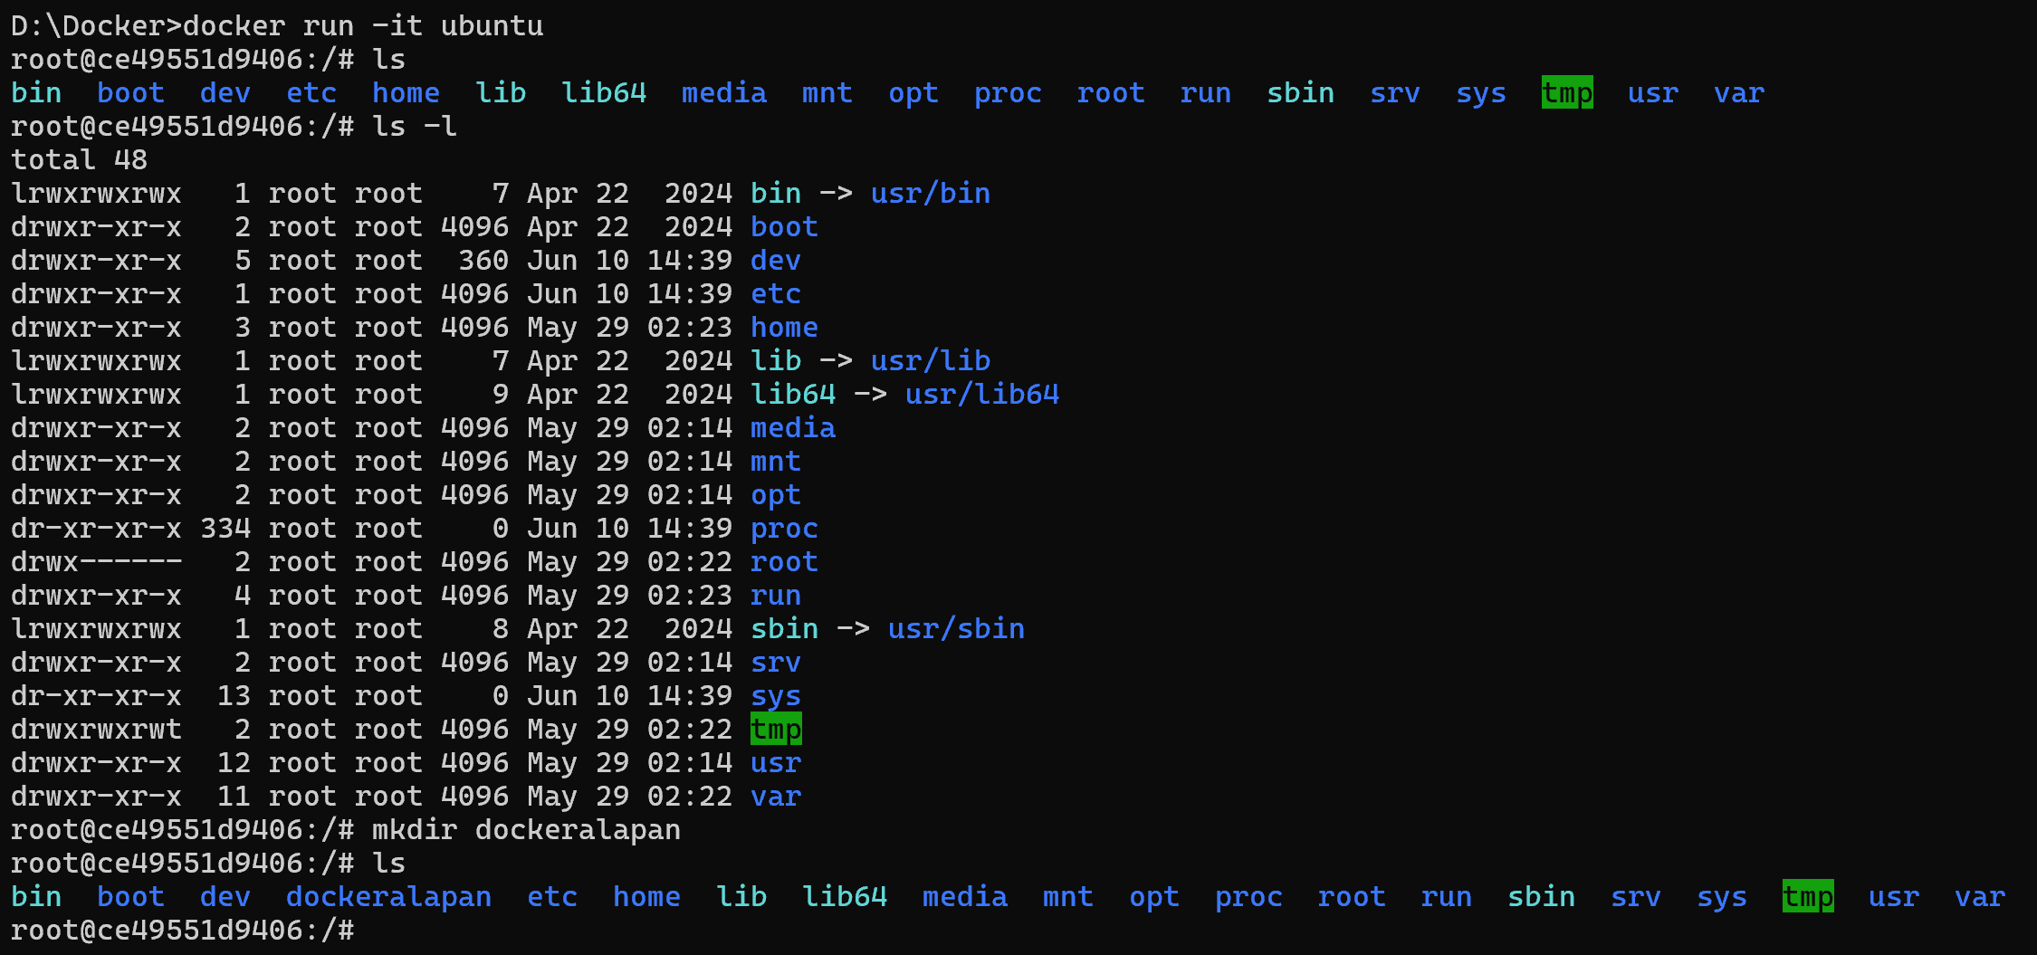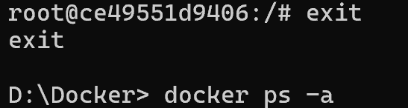

**docker ps -a: List all containers those are created**

**docker ps : List all running containers**

**docker start<id or name>: restart any created container**

**Start with id**

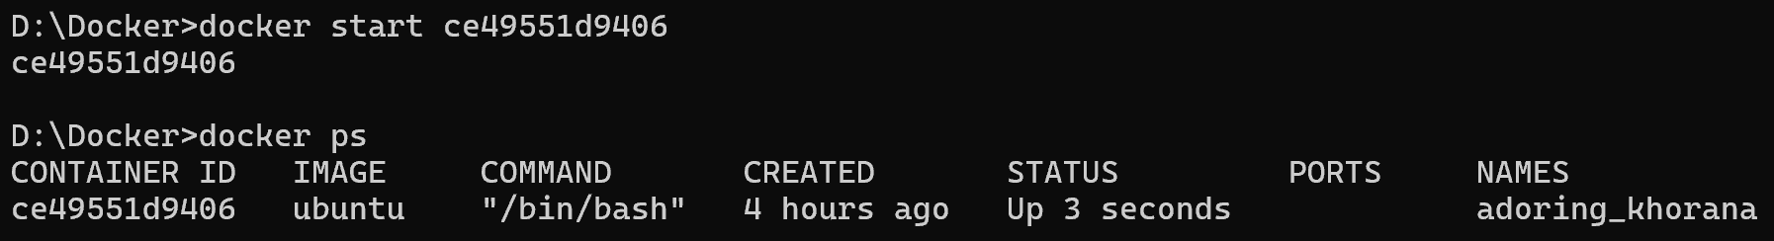

**Start with container name**

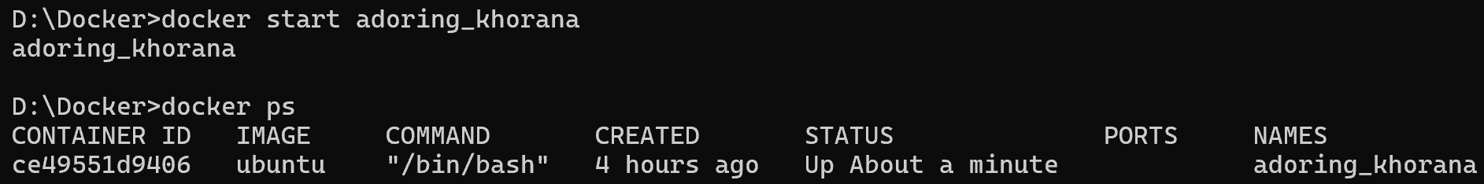

**Docker stop <id or name>: To stop any container**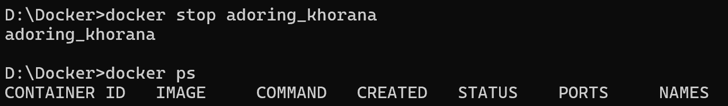

**rmi : To remove any image**

**Error because this image already has a container. To delete image we have to delete the container first.**

**rm : to remove any container**

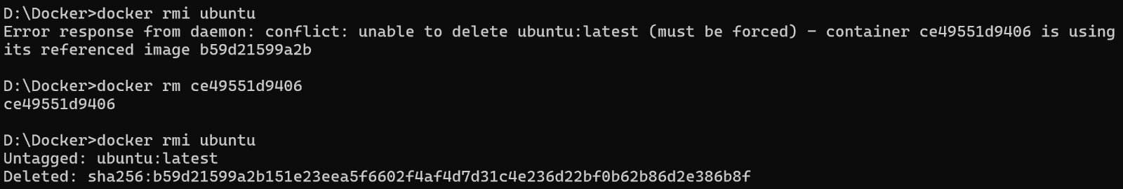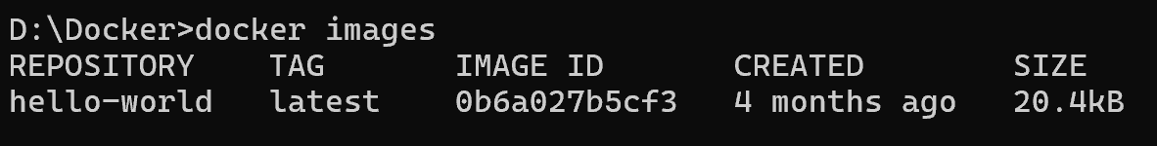

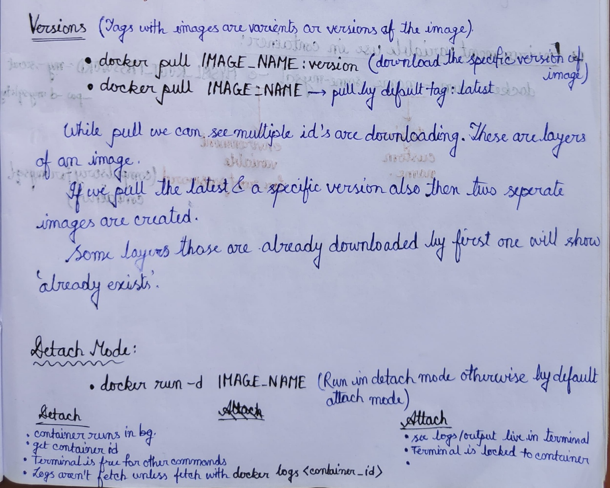

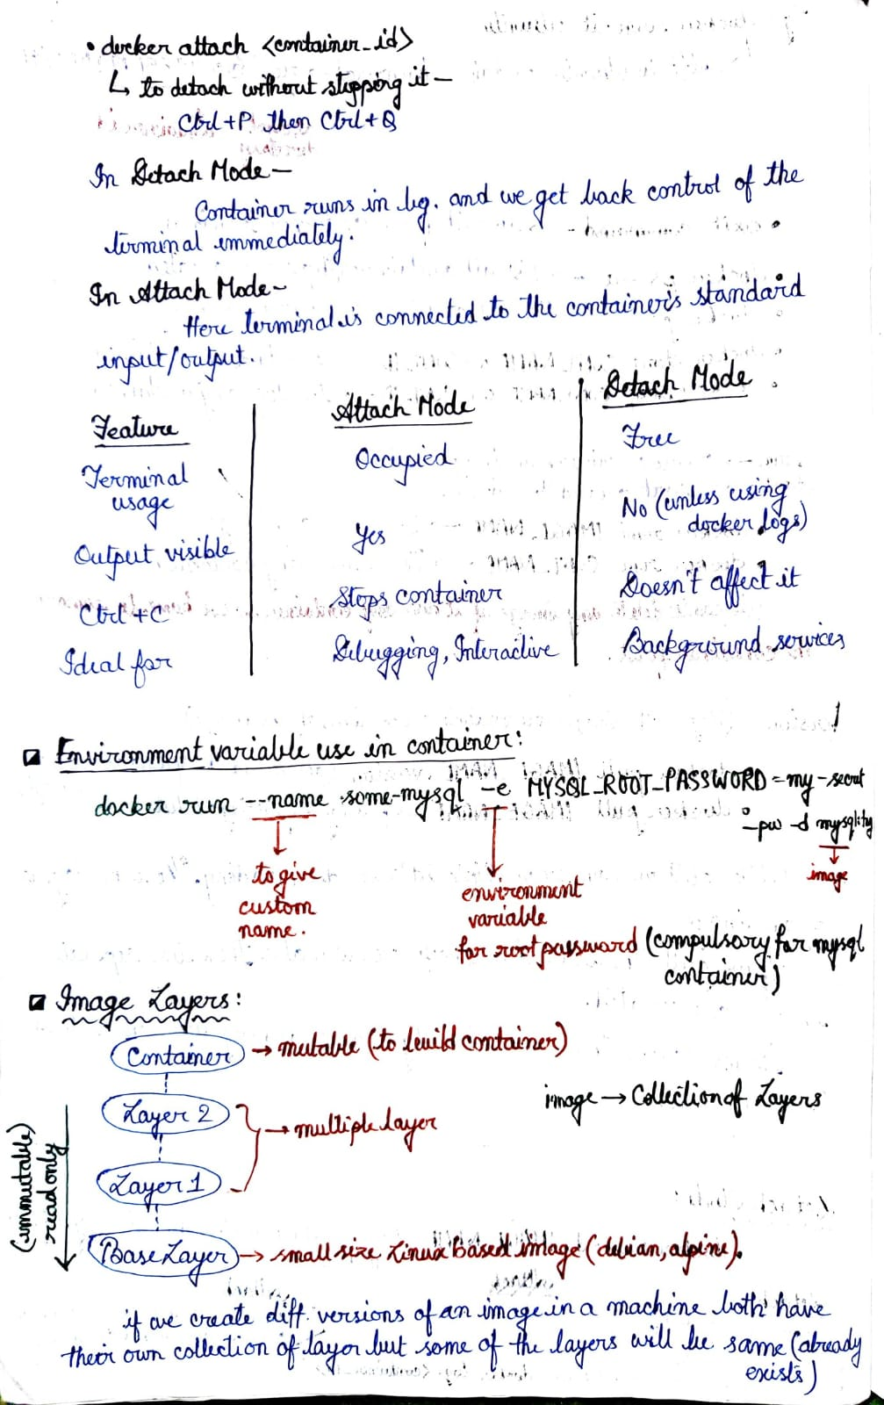

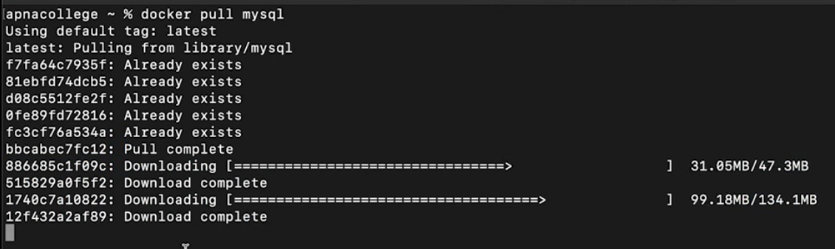

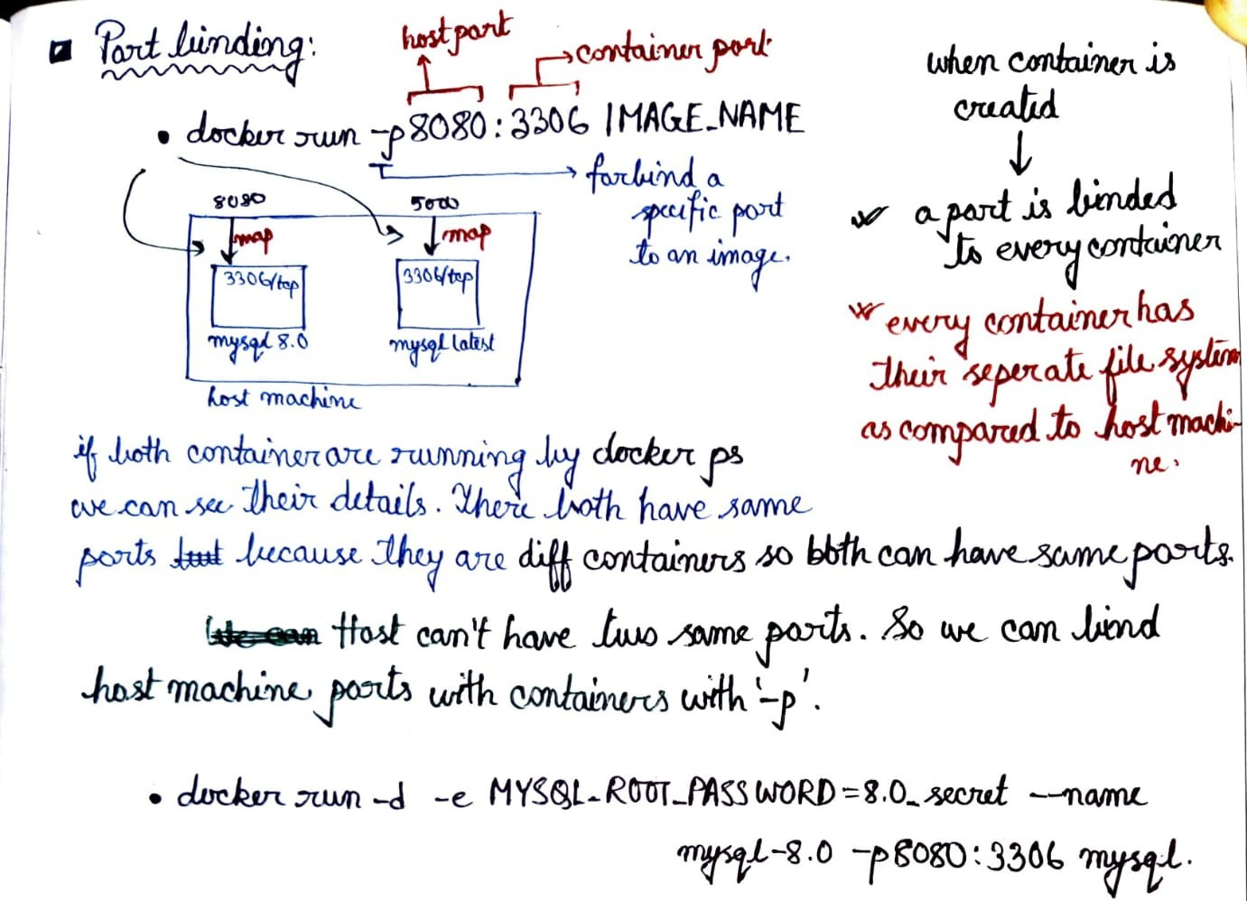

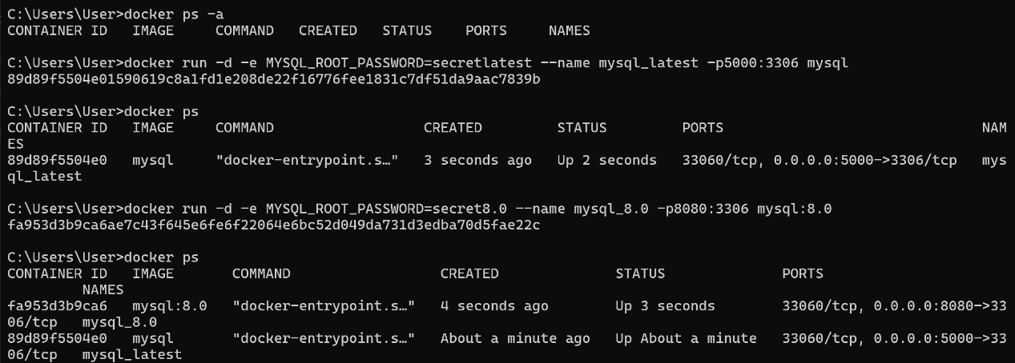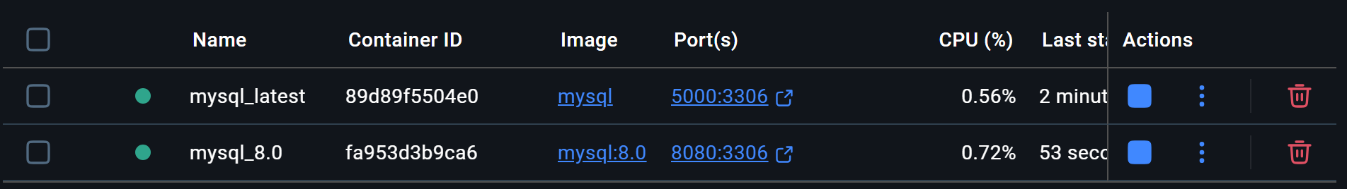

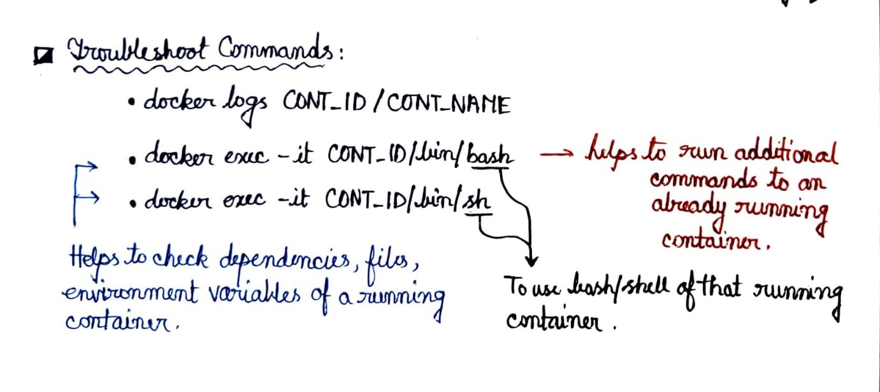

**Logs can also be checked from docker desktop by clicking the container name**

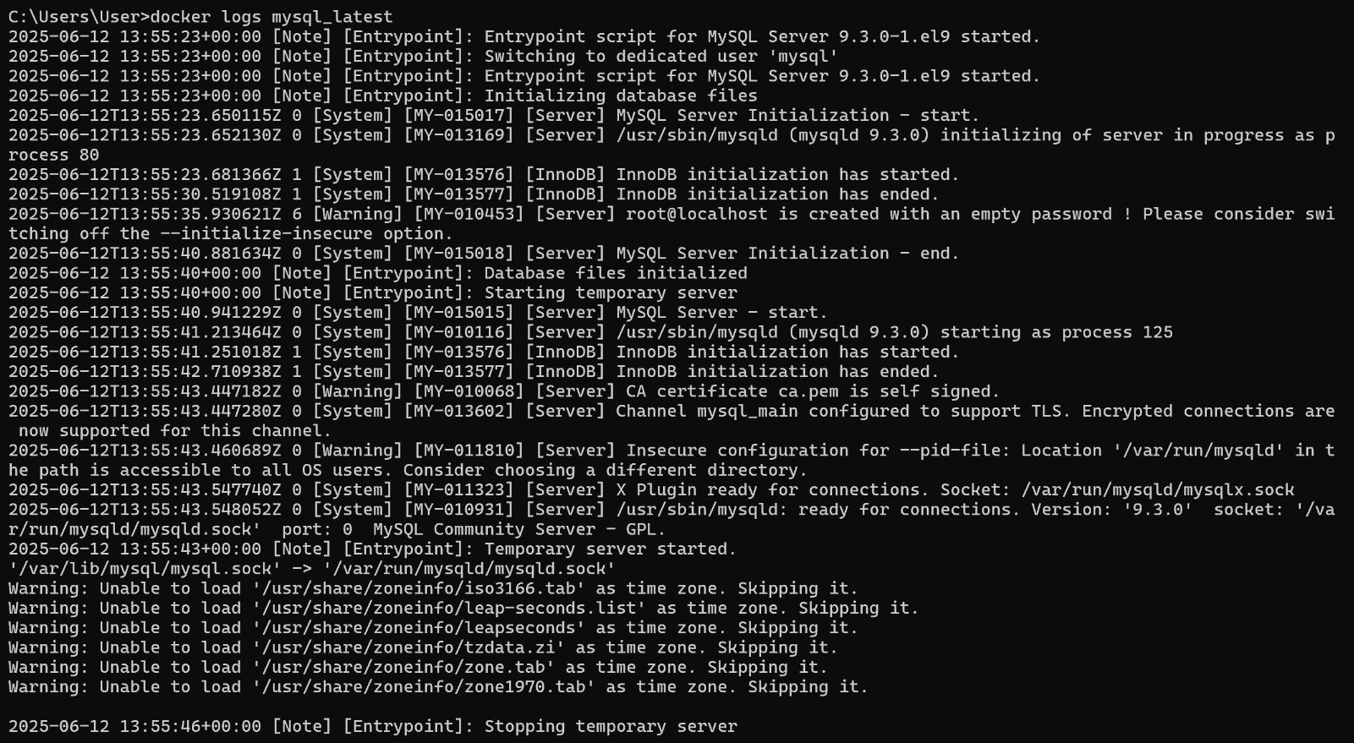

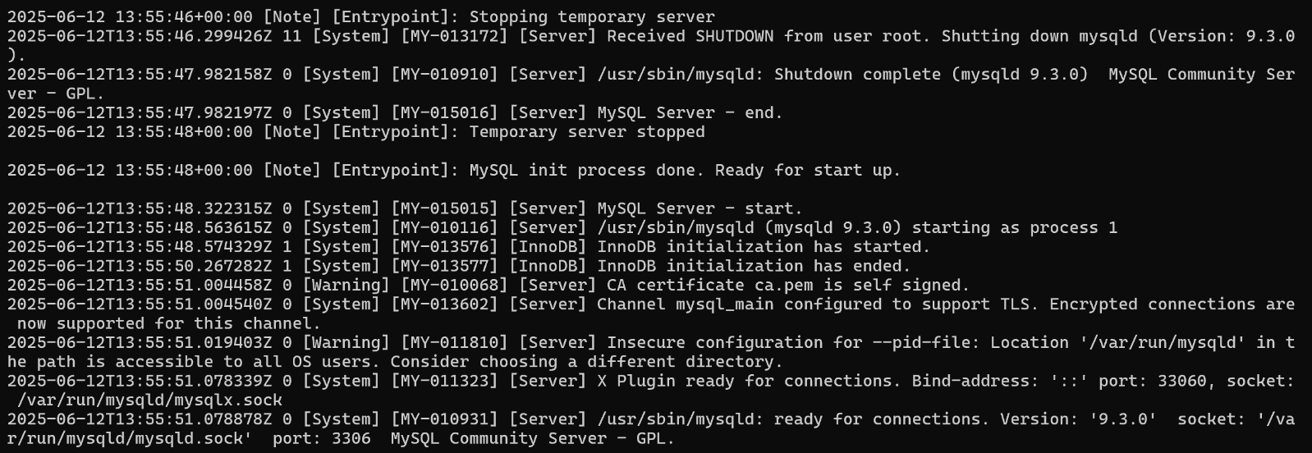

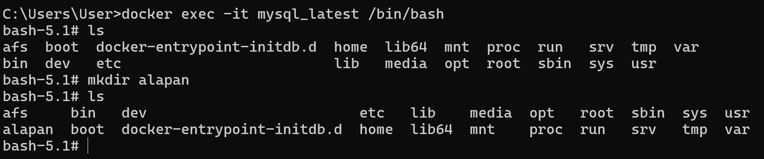

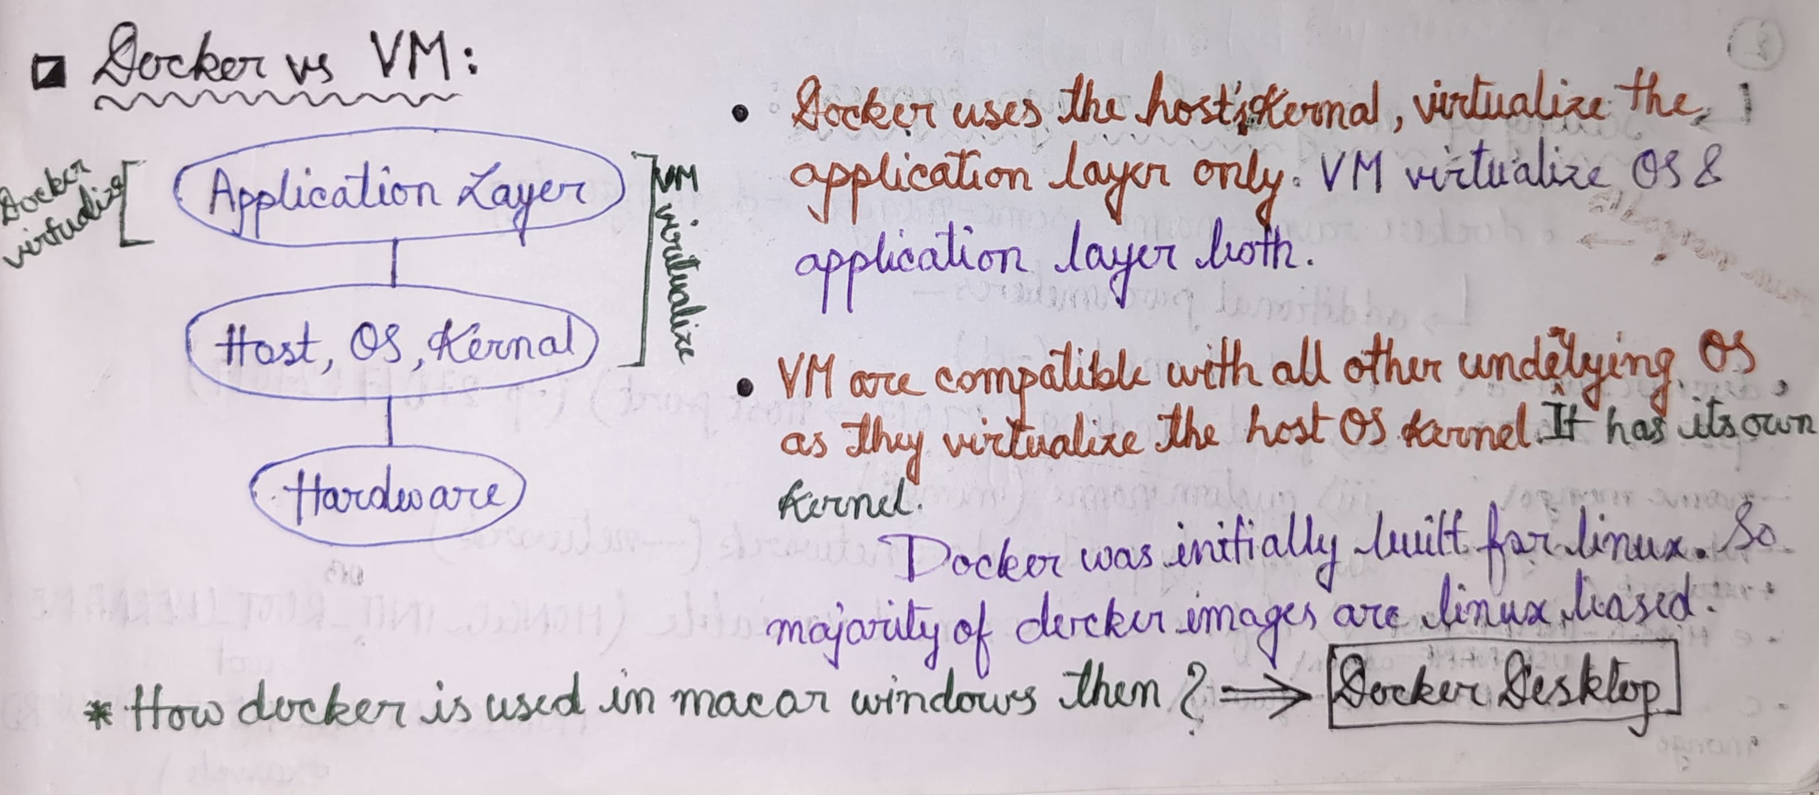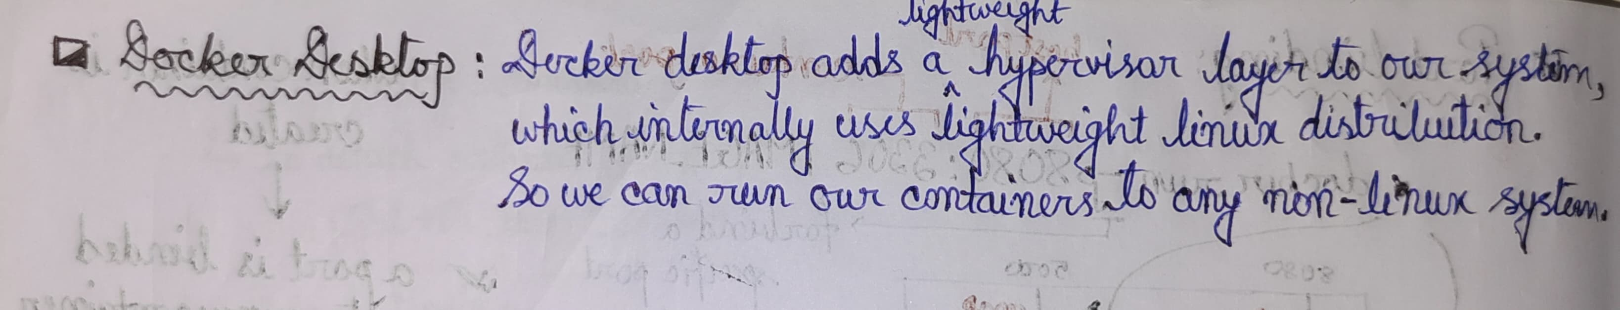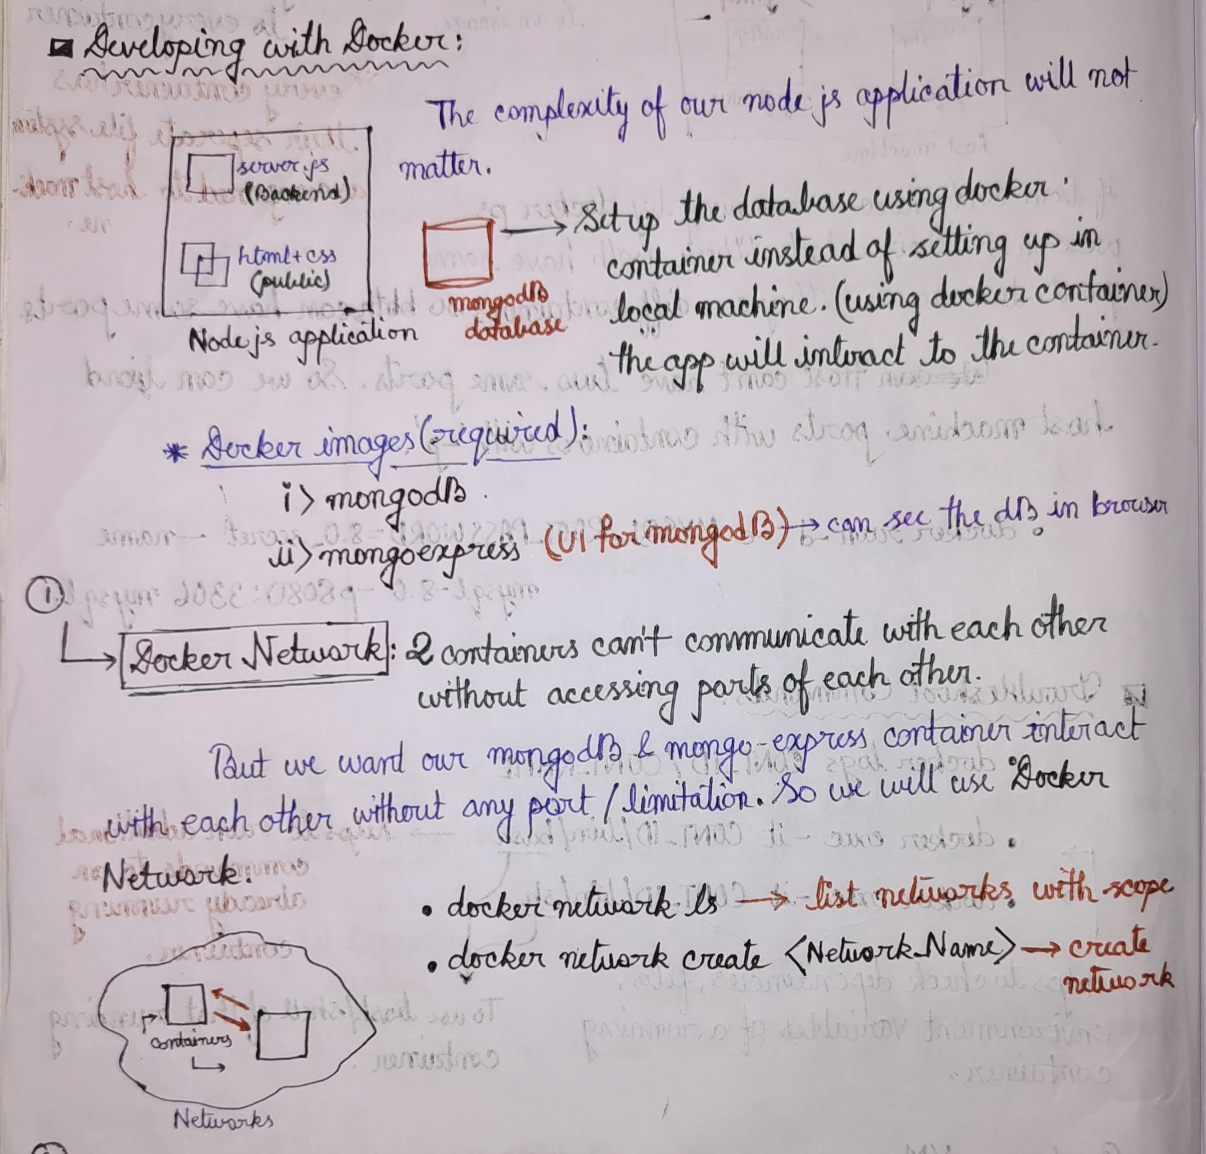

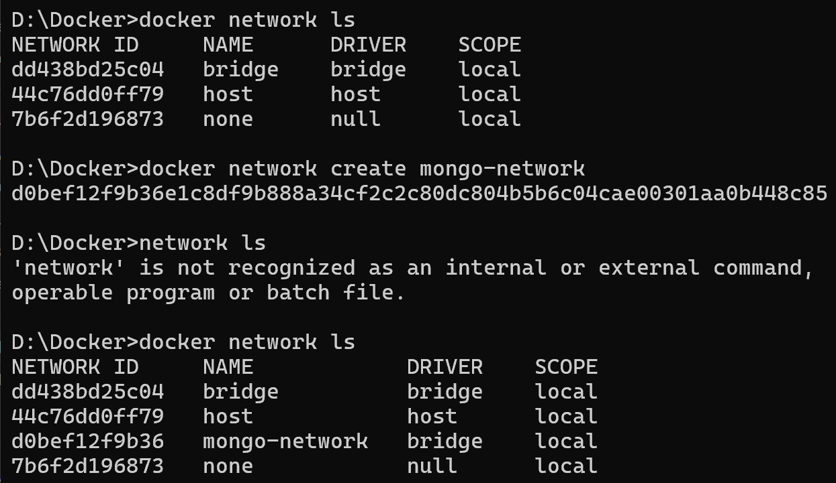

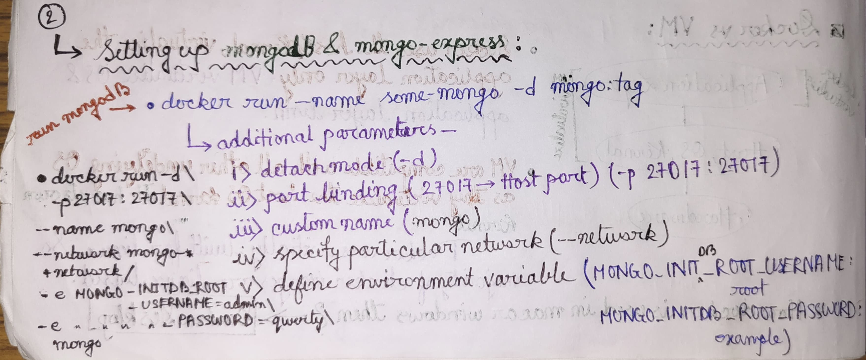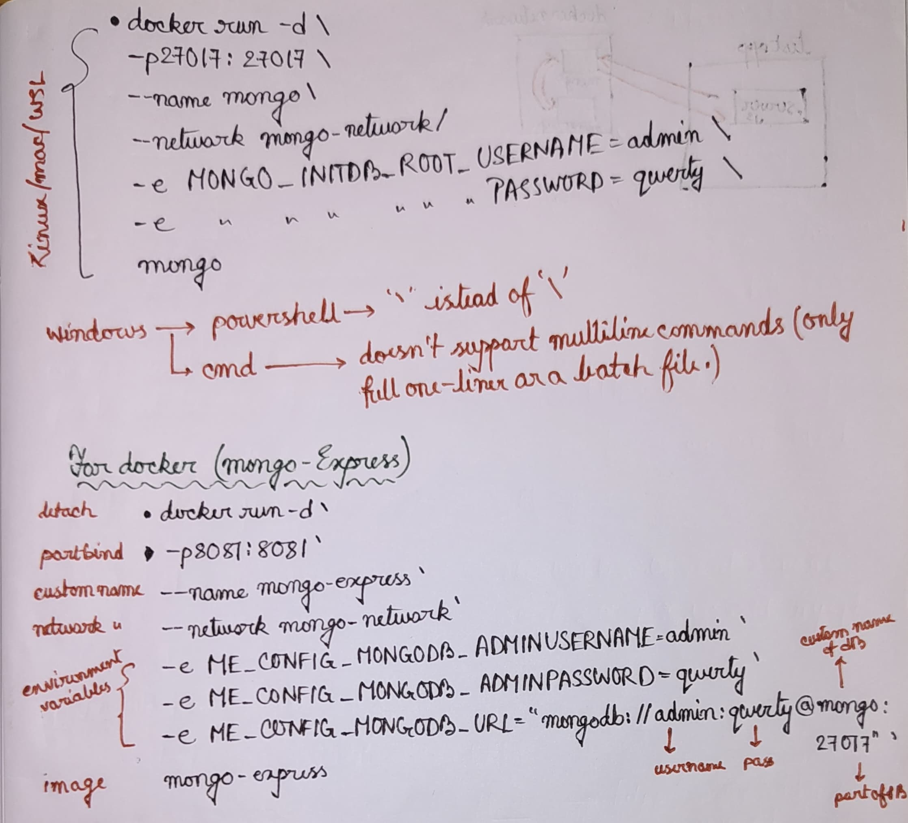

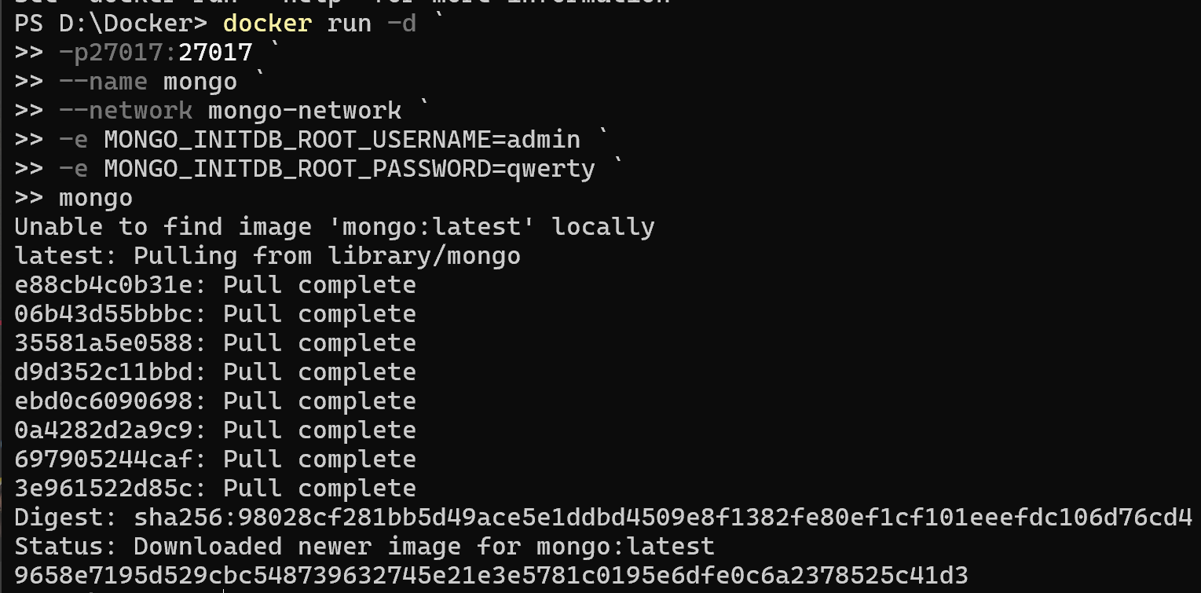

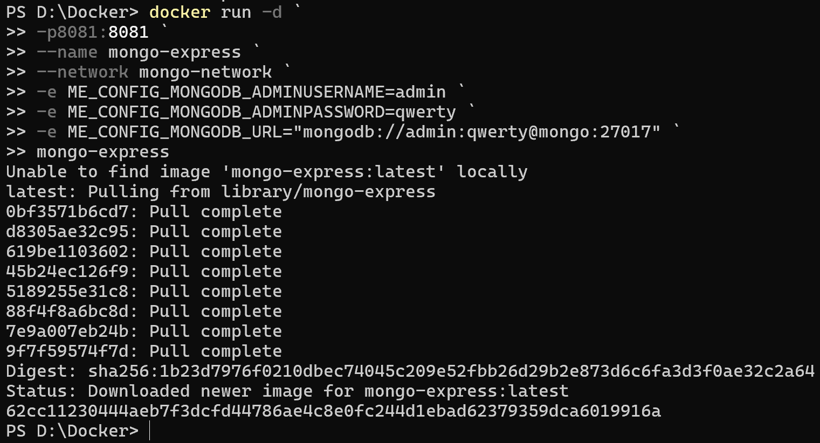

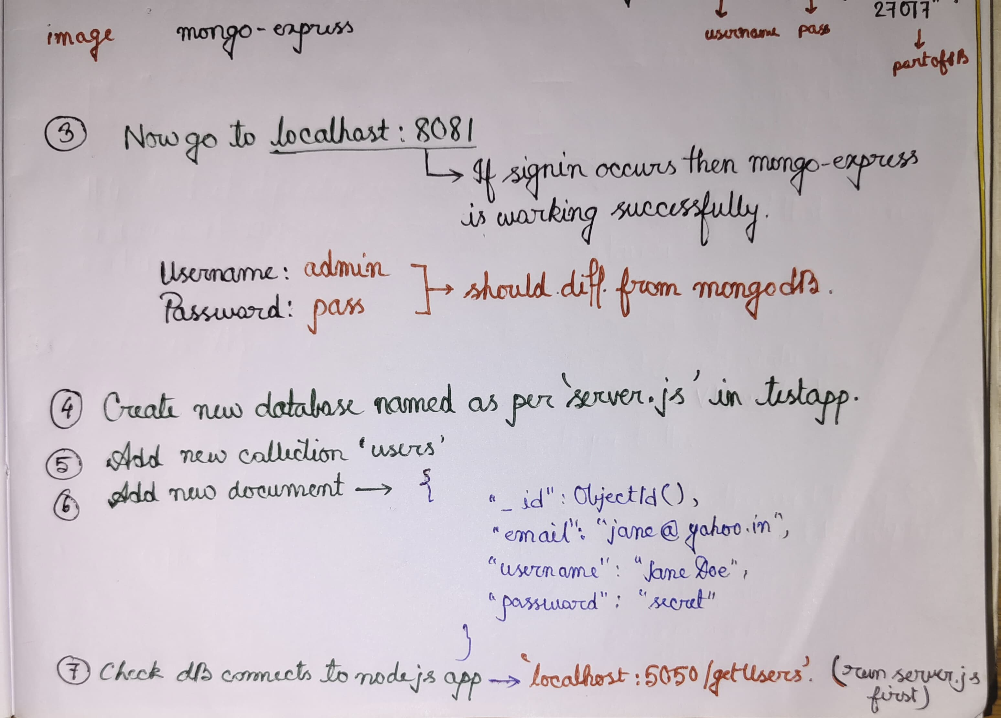

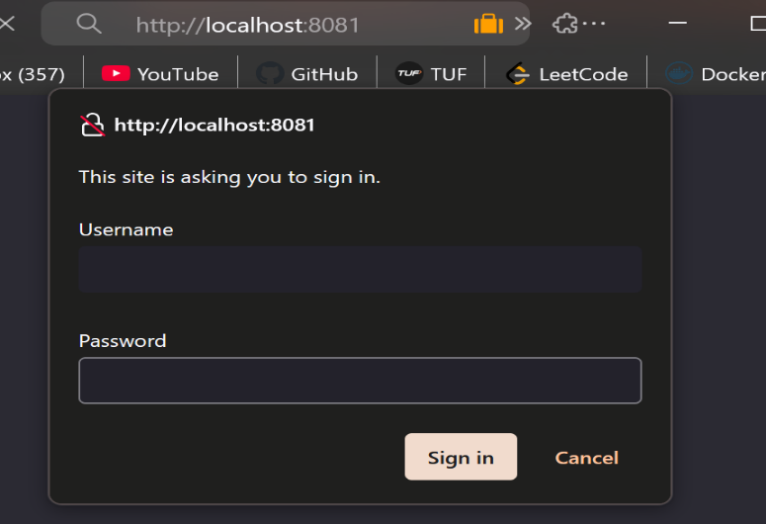3. 7.

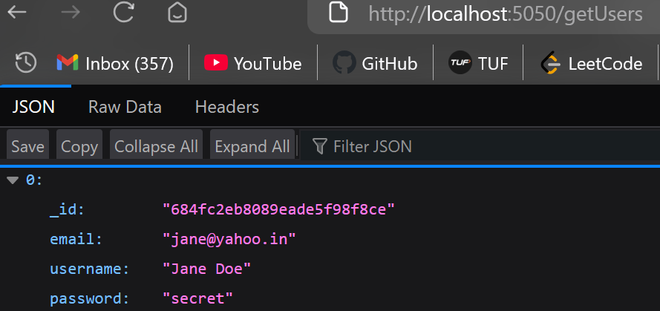

**Adding User to check:**

1. **Run the server.js and make sure the containers are running**
2. **Go to localhost:5050/**
3. **Fill credentials an create account**

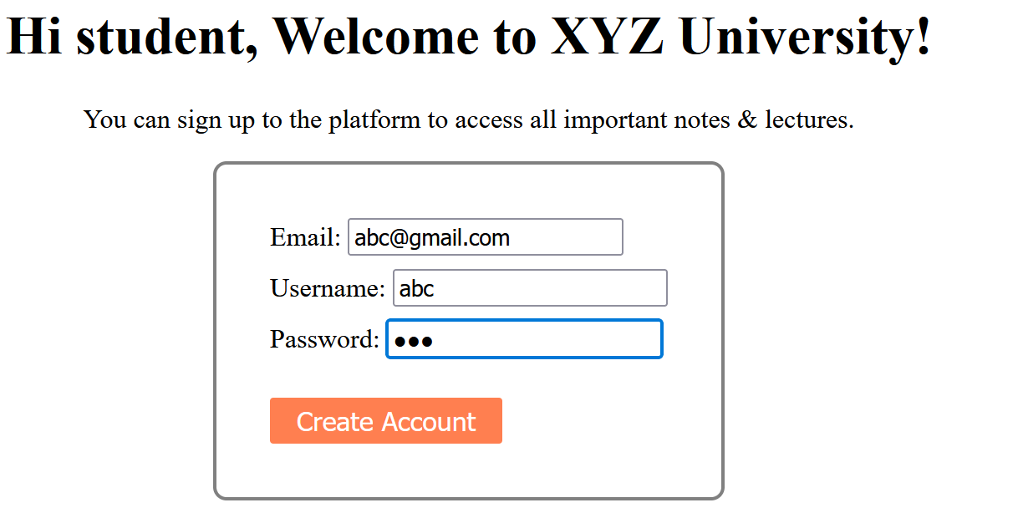

1. **In the terminal where server.js is running this will show(if successful)**

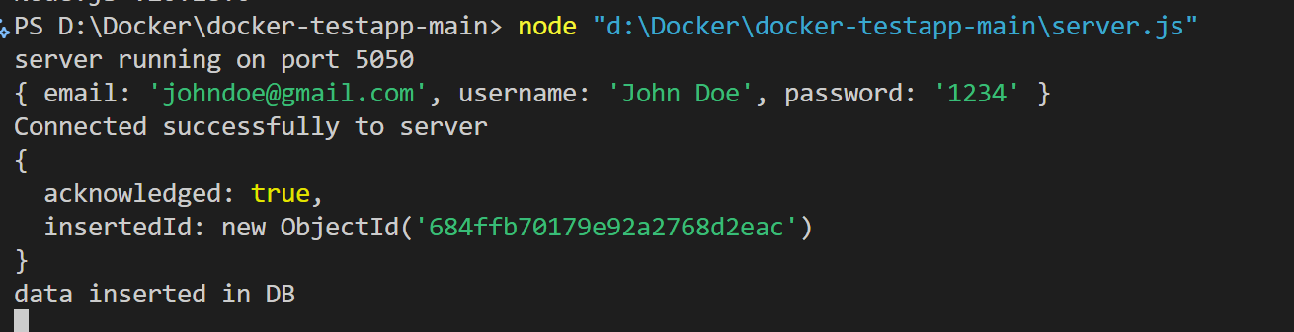

1. **Check at** [**http://localhost:8081/db/apnacollege-db/users**](http://localhost:8081/db/apnacollege-db/users) **to confirm through GUI.**

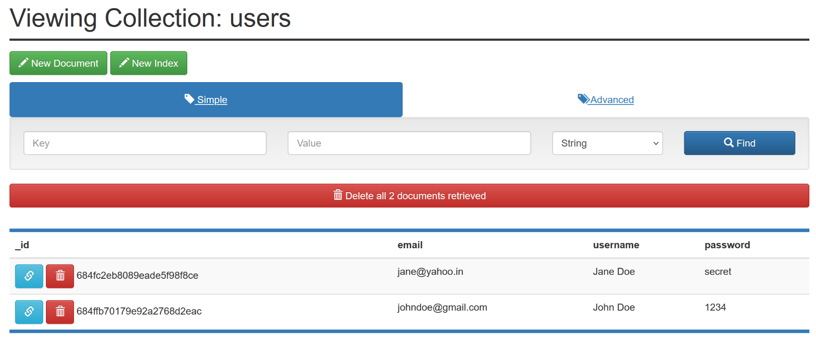

1. **Now check the** [**http://localhost:5050/getUsers**](http://localhost:5050/getUsers)

